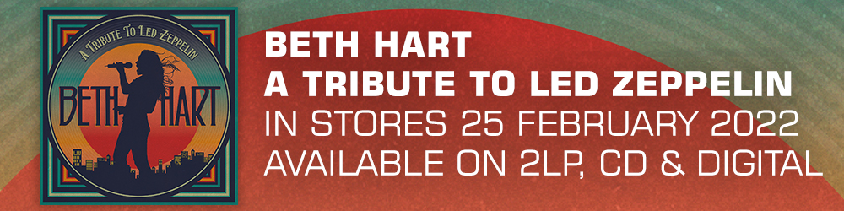

Beth Hart
New Album: A Tribute To Led Zeppelin
Release: 25 February 2022
Via: Provogue /Mascot Label Group

Listen to the first single: Good Times Bad Times
https://youtu.be/UXMzEGb0dqU

The Grammy-nominated powerhouse vocalist Beth Hart takes on one of her most profound undertakings to date by channelling the legendary voice of Robert Plant on A Tribute To Led Zeppelin. The album will be released on February 25 via Provogue/Mascot Label Group and will be available digitally, CD, and LP (Black vinyl, Orange transparent vinyl, and Splatter red gold vinyl).

The nine track album highlights the incredible musical spectrum that Led Zeppelin operated in. At the helm was super-producer Rob Cavallo (Green Day, Linkin Park, My Chemical Romance) and engineer Doug McKean (Goo Goo Dolls, Adam Lambert). The A-list musicians include Cavallo on guitar along with Tim Pierce (Bruce Springsteen, Tina Turner); on bass was Chris Chaney (Rob Zombie, Slash);on keyboards was Jamie Muhoberac (Bob Dylan, Rolling Stones); on drums was Dorian Crozier (Celine Dion, Miley Cyrus, Joe Cocker), and Matt Laug played drums on Stairway To Heaven (Alanis Morissette, Alice Cooper). Orchestral arrangements were by David Campbell (Muse, Beyoncé). All that was left was the final piece of the puzzle... the voice.

Things clicked into place when Cavallo was producing Hart's previous album, War In My Mind (2019), and she did an impromptu version of "Whole Lotta Love" in the studio. He later asked about doing a whole record. Beth said, "I'm not doing this whole album. To do Zeppelin, you've got to be pissed off to hit that right. I can't go there; I've worked years to put my rage away."

She continues, "then the pandemic and all the things around it hit. So now I'm pissed off. I called my manager and said, have Rob and Doug send me all the music because I am ready to do this."

If you were to rewind, you could say the story for a Led Zeppelin album started further back; in May 2004 Hart prowled the stage at the Paradiso in Amsterdam for an incendiary performance of "Whole Lotta Love". The song became a semi-regular fixture in her setlist over the years, including a memorable performance with Slash.

As a child, the sound of "Black Dog" traveled from Beth's neighbor's house into her orbit. Her brother introduced her to the heavy rock of Zeppelin and Black Sabbath. Her major-label debut came on Atlantic with the 1996 release of Immortal. The same label introduced Led Zeppelin to the world in 1969.

Earlier on in Beth's career, former VP of Led Zeppelin's Swan Song label, Alan Callan, recommended Beth contact Jeff Beck to work together. Hart and Beck have gone on to form a beautiful friendship. Beck and Jimmy Page are also friends, and for a while, bandmates in The Yardbirds. After Beck's departure from the band, they would eventually become Led Zeppelin.

After her phenomenal performance at the 2012 Kennedy Center Honors for Buddy Guy, she received a standing ovation from Robert Plant, Jimmy Page, and John Paul Jones.

It's fitting that "Whole Lotta Love" is the opening song of the album. From there, it's a non-stop journey through "Kashmir", an enchanting version of "Stairway to Heaven" to a James Brown-esque funky strut of "The Crunge." Inspired medleys "Dancing Days/When The Levee Breaks" and "No Quarter/Babe I'm Gonna Leave You Now" stand on both sides of "Black Dog." The penultimate song, "Good Times Bad Times" leads into the orchestral ballad "The Rain Song," which closes the album.

Talking about the music and legacy of Zeppelin, she says, "it's so beautifully done, it's timeless. It will go on forever. Sometimes people come along, and they're from another planet, and they make these pieces of art which will forever be."

Hart is recognized as one of her generation's most talented voices. She has sold out tours worldwide, including performances at historic venues such as Nashville's Ryman Auditorium, London's Royal Albert Hall, and the Ziggo Dome in Amsterdam. She's topped the Billboard Blues charts six times, gone double platinum and had a string of Top 10 charting albums across Europe.

On a final thought, Beth pauses and reflects to say, "this Zeppelin album allowed me to get all my rage out, and for that, I'm really grateful."

Beth Hart – A Tribute To Led Zeppelin | Track List | Extra Information
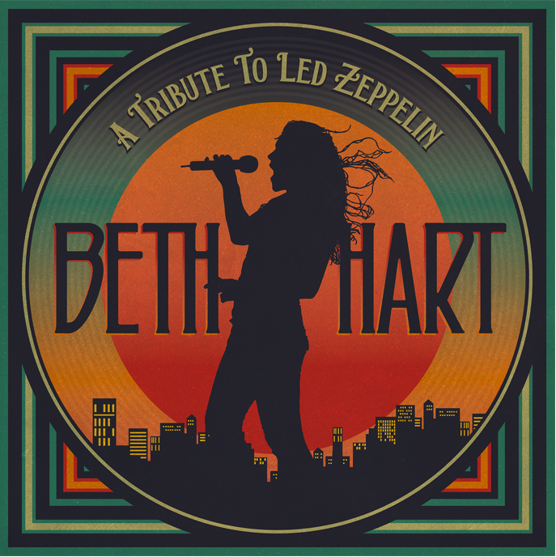 | - Whole Lotta Love  - Kashmir  - Stairway To Heaven  - The Crunge  - Dancing Days / When The Levee Breaks (Medley)  - Black Dog  - No Quarter / Babe I'm Gonna Leave You (Medley)  - Good Times Bad Times  - The Rain Song | Release Date  Feb 25, 2022  Available formats  CD/LP/Digital  Beth Hart Online  www.facebook.com/officialbethhart  www.twitter.com/BethHart  www.instagram.com/officialbethhart  www.youtube.com/user/BethHartMusic  www.bethhart.com

Editorial note/Not for publication:
For additional information, stream links, and interview requests, please contact:

Mascot Label Group is a 100% independent record company specialized in guitar-oriented music with a focus on rock, metal and (Blues) guitar. The company has offices in New York, London, Paris, Milan, Cologne, Stockholm and Rotterdam (headquarters).

Artists on the roster and in the catalogue include 10 Years, Ayreon, Kris Barras, George Benson, Black Stone Cherry, Joe Bonamassa, Doyle Bramhall II, Bootsy Collins, Crobot, DeWolff, Dragged Under, Flying Colors, Eric Gales, Paul Gilbert, Gov’t Mule, Beth Hart, Warren Haynes, Sonny Landreth, Jonny Lang, LEVARA, Steve Lukather, Yngwie Malmsteen, Monster Truck, Otherwise, Maceo Parker, P.O.D., Shaman’s Harvest, Kenny Wayne Shepherd, Jake Shimabukuro, Quinn Sullivan, The Georgia Thunderbolts, The Rides, Walter Trout, Robin Trower, VOLA, Volbeat, Leslie West, and more.

Owned and operated labels include Mascot Records – Provogue – Music Theories Recordings – Cool Green Recordings – The Players Club – Funk Garage.

